Diagrams for MyNotesApplication

SOA Microservices Project

Maior Alexandra, Software Engineering

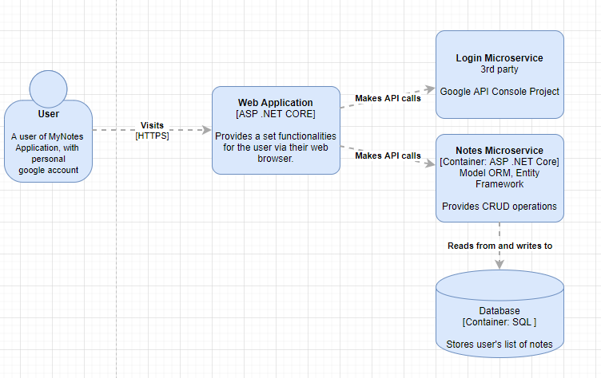

Diagram 1: C4 diagram – system description

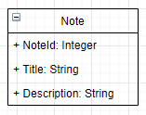

Diagram 2: UML diagram – Note class